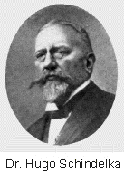
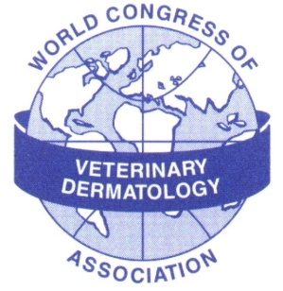
The Hugo Schindelka Award
The World Congress of Veterinary Dermatology Association invites nominations for The Hugo Schindelka Award
This award commemorates initiation of the scientific approach to veterinary dermatology and its establishment as a discipline in 1903 when Dr. Schindelka, a teacher at the Vienna Veterinary School, published his book, Hautkrankheiten bei Haustieren Handbuch der Tierärztlichen Chirurgie und Geburtshilfe (Skin Diseases of Domestic Animals) .
The Award
The award, a medal and US$ 5,000, and will be presented every 4 years at the World Congress of Veterinary Dermatology, beginning with the 6th Congress in Hong Kong in 2008. The recipient will be invited to attend and deliver a plenary lecture.
The World Congress of Veterinary Dermatology Association is pleased to
acknowledge generous sponsorship of The Hugo Schindelka Award in 2008 by
Interzoo Publishing and Blackwell Publishing
Purpose of the Award
The award recognises excellence in scholarship and publication in Veterinary Dermatology.
Scholarship includes organisation and development of the discipline, teaching at both undergraduate and postgraduate levels in universities and within other educational systems, and the development of diagnostic and therapeutic methods, courses and teaching material.
The recipient should have published a substantial volume of high quality material relating to veterinary dermatology with a significant impact on the discipline. Research papers should include new discoveries and publication in high impact journals.
All aspects of the discipline can be included and publications can be scientific papers, popular articles, books and electronic media. Candidates for the award do not have to have a veterinary qualification.
Nomination and Selection
Nominations for the first award are now invited and will be evaluated by an Award Committee established by and reporting to the WCVDA Board. Members of the WCVDA Board will not be eligible for this award.
Nominations should be submitted on the nomination form below and must be received by 15th February 2008. These documents are also available on the WCVDA website at www.wcvda.com.
Members of the Board of WCVDA are Dr. Didier-Noel Carlotti, Professor Richard Halliwell, Professor Peter Ihrke, Professor Toshiroh Iwasaki, Dr. Hans-Joachim Koch, Dr. Kenneth Kwochka, Professor David Lloyd, Dr. Chiara Noli, Dr. Manon Paradis, Dr. Phil Roudebush, Dr. Carmel Taylor
Hugo Schindelka Award Nomination Form
COMPLETE FORM ELECTRONICALLY USING MICROSOFT WORD OR COMPATIBLE SOFTWARE AND E-MAIL IT TO PROFESSOR DAVID LLOYD (dlloyd@rvc.ac.uk) By 15TH FEBRUARY 2008

Name of person nominated (please give full name and qualifications)
...........................................................................................................................................
...........................................................................................................................................
Name of nominator
...........................................................................................................................................
Qualifications
...........................................................................................................................................
Postal address
...........................................................................................................................................
...........................................................................................................................................
E-mail address
...........................................................................................................................................

Justification of Nomination
State briefly (less than 500 words) how the nominee fulfils the Purpose of the Award as specified on the previous page.

